**INTERNET OF THINGS**

**Project Report**



**Submitted to**

Dr. Purnendu Pandey

**Submitted by**

Kondragunta Murali Manohar Chowdary(15B00192)

Maddula Surya Aravind(15B00198)

P Sai Deepak(15B00249)

Maddikunta Chandra Sai Ram(15B00165)

Group-6

CSE-2

**A Novel Approach to Color Based Product Sorting in a Noisy environment**

Murali Manohar Maddula Surya Aravind

[kmanoharmurali@gmail.com](mailto:kmanoharmurali@gmail.com) [maddula.aravind.15cse@bml.edu.in](mailto:maddula.aravind.15cse@bml.edu.in)

Sai Deepak Chandra Sai Ram

[sai.deepak.15cse@bml.edu.in](mailto:sai.deepak.15cse@bml.edu.in) [chandrasairam.maddikunta.15cse@bml.edu.in](mailto:chandrasairam.maddikunta.15cse@bml.edu.in)

Purnendu Pandey

[purnendu.pandey@bmu.edu.in](mailto:purnendu.pandey@bmu.edu.in)

**Abstract**

State of the art techniques are used for sorting products into their particular categories in Industries and any relevant sectors.One of them includes bar-code scanning to sort the products.Color Based Sorting System is an approach of sorting the products based on its colors.It is believed to be an alternative for the bar code scanning approach and involves less overhead.It works on the principle of anding images with color boundaries and then selecting the color which is most dense in the image.It has been coded to perform accurately even in the noisy environments.This approach has shown us significant results.The products sorted for each area is noted and sent to the cloud for further data processing.We apply linear regression on the given data to decide which sector is most suitable to have a new warehouse.

**1.Introduction:**

**1.1 Overview**

Automation is the driving force of all industries.It is given much importance due to its capability of performing high quality work in minimal time and with minimal human intervention. Industries are looking out for ways to increase their productivity by exploring the concept of robotics and its automation.Large scale industries have enough funding for their R&D department to come up with new technologies.One such finding is the invention of barcodes for identifying things.

With the emphasis on “Make In India” campaign,there is a considerable growth in the small scale sector . Large scale industries have enough capital and technology to equip machinery even for smaller tasks , but that is not the case with small sector industries.To reduce the wastage of human resources in manual sorting of the products , various methods have been proposed.A person who is performing the same task repeatedly may fail at same time.Failure in sorting the products will result in the wastage of time for both consumer and logistics service companies.Product Sorting is one field where errors are extremely costly. As this work focuses mainly on alleviating the situation of product sorting,let’s see how it is done in the large scale industries. In large scale industries, barcode scanners and generators are used in order to sort the products as per their categories.

The problem with the existing technology is the overhead involved in cost and time because of the exchange of information with the cloud for every product.Industries will have to stop working if there is a network problem and besides that , small scale industries can’t afford high infrastructure and also ,can’t afford wastage of human resources for manually sorting the products.Moreover accuracy can’t be assured by manual sorting.

We propose a new approach of sorting the product in this paper which sorts the objects by their colors and distributes them to different containers respective to their locations.We believe that this method can be an cost effective alternative to the current and better alternative to the traditional sorting techniques.

**1.2 Methodology**

There has been few works based on color sorting by color sensor TCS320-2300 for color detecting, but the sensor is not effective on opaque objects and as color pasted on product will be opaque , color sensor is not a good option.We ourselves, have tried using color sensor,but could not achieve the required performance and accuracy.[1]

In this method,we propose using a webcam to capture the image of the product ,which is pasted with its assigned color, from the top view and process it for detecting the image.We use a procedure called “bitwise-anding” which will be explained in “Proposed Algorithm” section.We get an image created for every “bitwise-and” operation ,where the created image contains the pixels of a particular color in it and remaining color pixel values are made zero.After having the images,the color corresponding image with large number of non-zero pixel values is chosen to be the most dominating color.

After sending the data to the cloud, Linear Regression is performed to find out the actual contribution of each area to the orders placed.The optimal place is reported to the concerned authority on regular intervals.

This method not only ameliorates the situation of small scale industries but also at the reception of colleges where orders are placed in unsorted order without any distinction between type of customer.

**1.3 Objectives**

* To make the sorting procedure more effective by image processing.
* To minimize the human intervention in the whole sorting process.
* To perform data analytics on the orders to decide which area is more eligible to have warehouse.
* To minimize the overheads involved in the process.
* To make the system run independently without the need of internet in adverse conditions.

**2.Literature Survey**

Two different conveyor belts are used, first one is above the second one. Initially the object is placed on the first conveyor belt, there is a color sensor fixed above the first conveyor belt. When falls on the object is reflected back to the color sensor the color of the object is detected by the color sensor. Second conveyor belt has three containers each assigned for individual color(red, green, blue) based on the color detected the objects fall into their respective containers. If the color detected is black(no color), the object is discarded "Automatic Color Sorting Machine Using TCS230 Color ... - Saintgits." <http://journals.saintgits.org/paper-submission/uploads/article/V2%20I2%2005.pdf>. Accessed 24 Apr. 2018..

To identify the destination area of the package we use color based sorting, where each area is represented by a specific color. According to the color detected by the program in raspberry pi, the packages are placed in the boxes of specific areas with the help of conveyor belt "Real-time color-based sorting robotic arm system - IEEE Xplore." <http://ieeexplore.ieee.org/document/8053385/>. Accessed 24 Apr. 2018 .

The different components we used in our project are Ultrasonic sensor, servo motors, Dc Motor, BreadBoard and Raspberry Pi "Sorting of Objects Based on Colour, Weight and Type ... - IOSR journals." <http://www.iosrjournals.org/iosr-jmce/papers/Conf.RDME%202017/Volume-6/2.%2004-07.pdf>. Accessed 24 Apr. 2018. Major part of our project is Software interfacing of Raspberry pi with all components. Servo motor is directly connected to the raspberry pi, rotation angle of servo depends on the color detected specific angle is designated to every color, working of the servo entirely depends on the function used in raspberry pi <http://www.instructables.com/id/Servo-Motor-Control-With-Raspberry-Pi/>. Ultrasonic sensor is connected to raspberry pi through BreadBoard, when the ultrasonic sensor detects the package image is taken and is processed for detection of the color <https://www.modmypi.com/blog/hc-sr04-ultrasonic-range-sensor-on-the-raspberry-pi>.

Swain and Ballard proposed Color histograms as a first attempt for recognition of objects. The study of image processing and algorithm for the same studied by "Digital Image Processing ", which includes threshold value of an object image, image histograms, RGB color palette working , suppression of the background data, color recognition and various other operations."colour sensor based object sorting robot - irjet." <https://www.irjet.net/archives/V4/i8/IRJET-V4I891.pdf>. Accessed 24 Apr. 2018. In our project we convert the image into matrices and we create a image with only the pixel values present in boundary value of color with highest proportion in the image.

**3.IoT Architecture:**

We have four stages of IOT architecture implemented in our project.they are

**Things:**  In this layer,we have smart objects like ultrasonic sensors and servo motors.DC motor is also used for the working of conveyor belt.

**Gateway:** We used Raspberry as gateway in our project because of its capability of performing high end operations.

**Internet**: We use wifi module which is inbuilt in raspberry pi.

**Services:** In services we will do Data processing and ML part

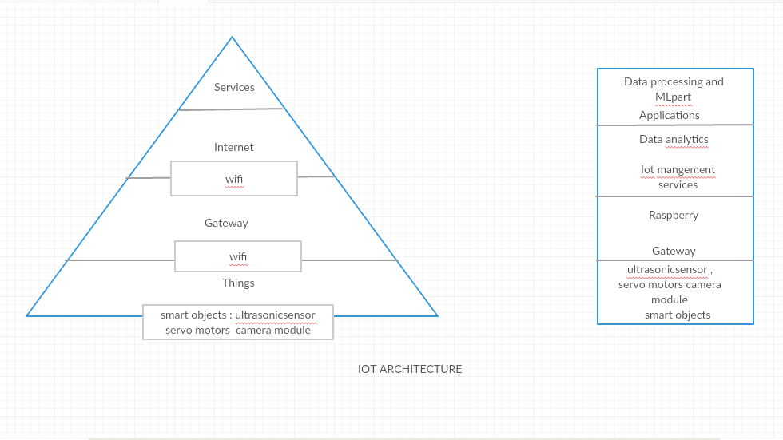

We are using star topology in our project as all the communication goes through the gateway i,e ultrasonic sensor sends a signal to raspberry pi and raspberry pi uses wifi module to connect to the camera module for taking a pic .Camera module sends the image to raspberry pi .After processing and detecting a color,it sends the signal to servo motor to move in a specified direction.

We use wifi module because it covers the distance of 1 to 1.5 Kilometres, and its connects a whole industry with single connection .

**4.Proposed Algorithm:**

Our approach focuses on sorting the products based on their color.For color detection, we have focussed on image processing instead of using color sensor because of its inefficiency.Following algorithm is used for color sorting:

*While True:*

*1. i f the object is detected:*

*2. image=Take image()*

*3. color=Process the image(image)*

*4. Send “color” to the servos*

*5. Increment “counter[color]”*

*6. if time==closing time:*

*7. Send values to the cloud*

*8. Clear the counters of the colors*

**Where*,***

*Process the image(image):*

*1. Convert the image into matrices*

*2. for each color in colors:*

3. *newimage=”bitwise-and” with “image” and “color” boundaries*

where “bitwise -and ” operation creates an image with only the pixel values present in between the boundaries.

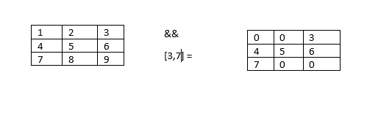

**Fig. 1 : “Bitwise and” operation**

*4. Note the no. of non zero pixels which shows density of the current “color” pixels*

*5. We have #|color| number of images where only pixels related to the color are high*

*Find the “color” whose corresponding image has more number of pixels.*

*6. return “color”*

One may think that there is no need of machine learning algorithm like Linear Regression.One way of considering the area with maximum orders is by averaging the orders of each area and then finding the area with maximum average.But the problem is , we can have skewed examples like one day , an area(Area1) can have 2000 orders but during other days,it has orders in the range of 10-100.While other areas may have orders in the range of 100-500s consistently.When we take the average of the orders of areas, we will get Area 1 to have highest average.But this is not true,because it is only one day that Area 1 has received has orders of that huge range,but in the case of other areas, same range of orders are observed everyday, so arranging warehouse in Area 1 is not really a good idea.Hence the notion of considering average must be dropped.

Linear regression deals with this situation as we write an equation for this in the below form:



Our parameters $θ_{1}$, $θ_{2}$, $θ_{3}$ gives the weightage of each area to the averaged orders of the whole total.We then consider the *Area_i* with $θ_{}$_*i* which is the maximum of all the parameters.

**5.Experiment and Simulation Setup :**

As we are making a “Color Based Product Sorter”,the components required are:

* **Camera Module :** For sorting the products by detecting the color.
* **UltraSonic Sensor:** It measures the distance of an object from a point with the help of sound waves.It is achieved by transmitting a sound wave at a particular frequency and listening for that wave to come back.
* This will be used to detect the product placed on the conveyor belt and when an object is detected,it will send a signal to the gateway(arduino),which in turn instructs the motors placed in conveyor belt to stop and brings down the color sensor to scan the product.An IR sensor can also be used instead off UltraSonic sensor but we have chosen UltraSonic sensor since the products can be too small and IR sensor may not cover the range.
* **DC Motors:**We are using them since we have to provide motion to the conveyor with minimal power.
* We are using Raspberry Pi since it is capable of complex computations like image processing,posting data to the cloud unlike Arduino boards.
* **Servo motors:** We are using them for directing the product towards its particular storage.Its beneficial to use servo motors since their input is an angle and they move according to the angle specified.

We will primarily use one camera module and two ultrasonic sensors.

Along with the sensors we will be using two servo motors for directing the product towards its particular storage and DC motors for controlling the motion of conveyor belt.

* **Software used:** Numpy,OpenCV,IP webcam,Python
* **Numpy:** NumPy is a Python programming library, it provides support for multi-dimensional arrays and matrices, complex mathematical operations work on these arrays.
* **OpenCV:**OpenCV is a library for processing the image.It basically converts the images into matrices.
* **IP Webcam:** IP Webcam transforms your mobile phone into a camera with various viewing options. Flash player or any web player can be leveraged to view the camera at any stage.
* **Python:** Python is a high level programming language providing rich source of libraries which help us perform image processing,machine learning operations.

**Hardware Configuration:**

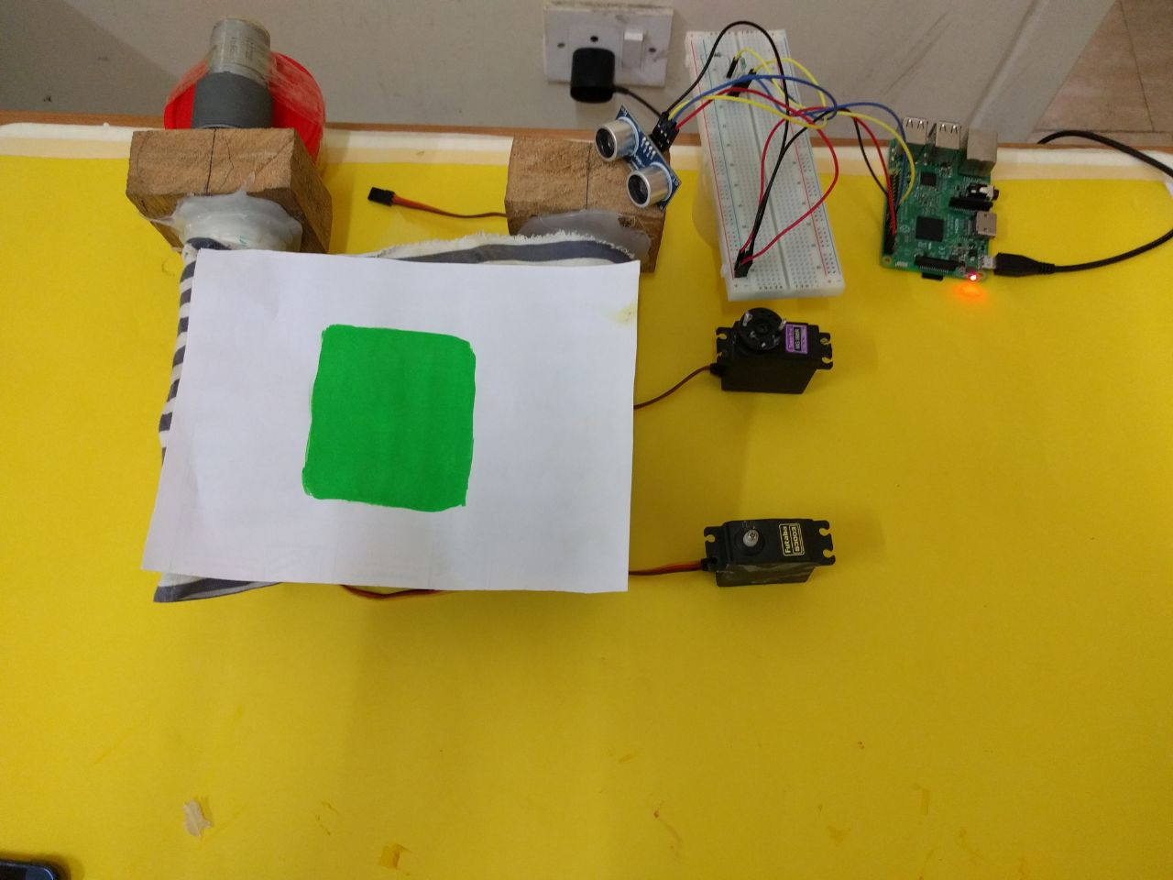

**Fig .2 : Hardware configuration**

If a product is detected by the Ultrasonic sensor, placed on the midst of the conveyor belt ,it sends signal to the raspberry pi which in turn stops the DC Motor and sends signal to the IP Webcam to click the picture of the object. Raspberry pi detects the color of the image clicked by IP webcam. Then servo motor is set to an angle depending on the color which is detected by Raspberry pi and the object is delivered. Every day the data is collected and stored in cloud after the work is completed.

**6. Results and analysis:**

The data is be sent to thingspeak on a daily basis through wifi and it can be shown in graph,there is no need to send the data for every 15 seconds because we are sending a summary of a whole day to thingspeak.

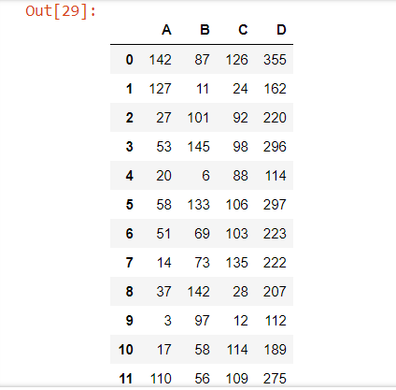

The data will be generated in the above form.After fitting the data to the above equation ,we get the parameters as follows:

$$θ_{1}=1.965944667568112e-31$$

$$θ_{2}=2.6438731030463845e-31$$

$$θ_{3}=1.5745161416860162e-31$$

**Fig. 3 Results obtained after applying Linear regression part**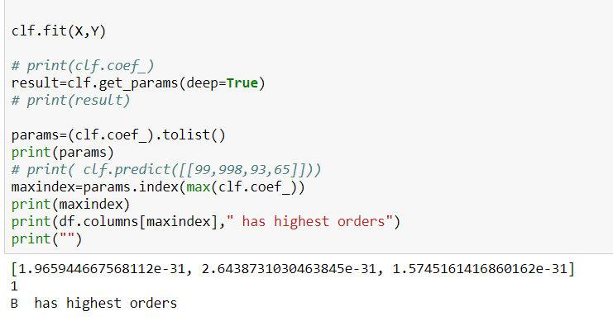

The next step is to perform data processing and finding out which sector is having and send summary to concerned person for a every month.We are fitting the data to the linear regression in the above figure.

After fitting the data to the above equation ,we get the parameters as follows:

$[1.965944667568112e-31, 2.6438731030463845e-31, 1.5745161416860162e-31]$ are the coefficients

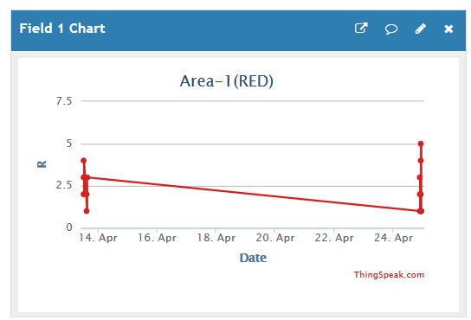

We can see that there are 4 objects related to Area 1 scanned on 24th april. two objects on 14th april, the value on 14th april is in range in between of 2.3-3 and in 24th it reaches maximum of 5 because increase in red color orders

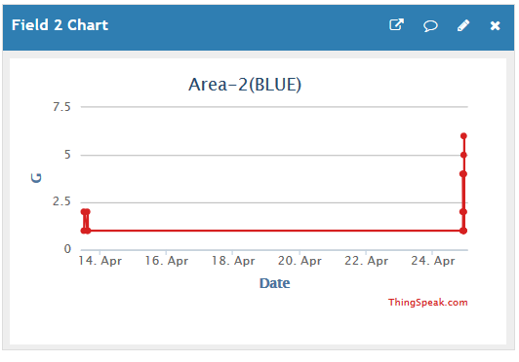

We can see that there are five objects related to Area 2 scanned on 24th april. four objects on 14th april, the value on 14th april is in range in between of 1-2.3 and in 24th it reaches maximum of 6.5 because increase in blue color orders

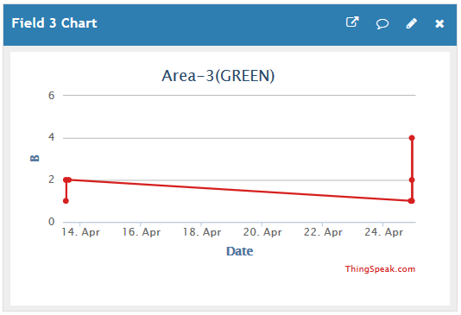

We can see that there are three objects related to Area 3 scanned on 24th april. two objects on 14th april, the value on 14th april is in range in between of 1-2 and in 24th it reaches maximum of 4 because increase in green color orders

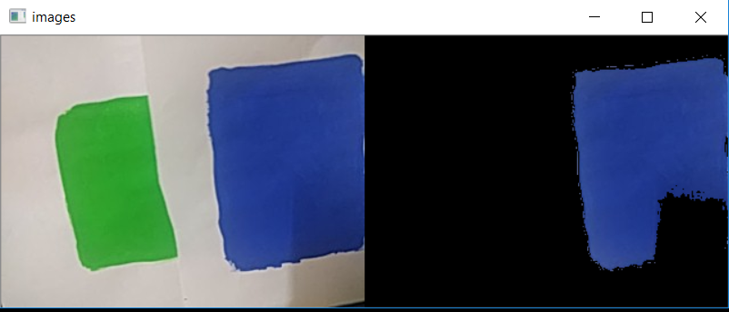

The above figure shows the “bitwise and” operation ,where the original image on the right is “bitwise - anded” with the boundaries of the blue color to extract the specific color from the original image

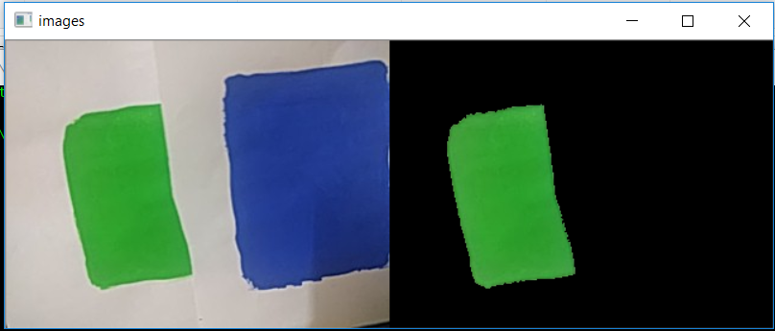

The above figure shows the “bitwise and” operation ,where the original image on the left is “bitwise - anded” with the boundaries of the green color to extract the specific color from the original image.

**6.Conclusion and future work:**

We have successfully built a working prototype of the proposed method which we expect to be deployed in industries in near future.Data is sent to the cloud , where it can be downloaded in the form of .csv file (comma separated values) and data analysis is performed on it for deciding the location which has more number of orders.

More advanced techniques for noise reduction can be implemented.Conveyor belt system can be more advanced.We would like to explore technologies such as Zigbee in our project etc.More features like product size , warehouse fullness detection can be added.

**7.References:**

1."Automatic Color Sorting Machine Using TCS230 Color ... - Saintgits." <http://journals.saintgits.org/paper-submission/uploads/article/V2%20I2%2005.pdf>. Accessed 24 Apr. 2018.

2. "Real-time color-based sorting robotic arm system - IEEE Xplore." <http://ieeexplore.ieee.org/document/8053385/>. Accessed 24 Apr. 2018.

3. "Sorting of Objects Based on Colour, Weight and Type ... - IOSR journals." <http://www.iosrjournals.org/iosr-jmce/papers/Conf.RDME%202017/Volume-6/2.%2004-07.pdf>. Accessed 24 Apr. 2018.

4. "colour sensor based object sorting robot - irjet." <https://www.irjet.net/archives/V4/i8/IRJET-V4I891.pdf>. Accessed 24 Apr. 2018.

5.<https://www.modmypi.com/blog/hc-sr04-ultrasonic-range-sensor-on-the-raspberry-pi>.

6.<http://www.instructables.com/id/Servo-Motor-Control-With-Raspberry-Pi/>.

1. "colour sensor based object sorting robot - irjet." <https://www.irjet.net/archives/V4/i8/IRJET-V4I891.pdf>. Accessed 24 Apr. 2018.